A Fast Topological Parallel Algorithm for Traversing Large Datasets

Thiago Nascimento Rodrigues
Regional Electoral Court of Paraná, Curitiba, 80.220-902, Brazil
E-mail: nascimenthiago@gmail.com
ORCID iD: https://orcid.org/0000-0002-2845-2717

Received: 25 September 2022; Revised: 28 October 2022; Accepted: 09 November 2022; Published: 08 February 2023

Abstract: This work presents a parallel implementation of a graph-generating algorithm designed to be straightforwardly adapted to traverse large datasets. This new approach has been validated in a correlated scenario known as the word ladder problem. The new parallel algorithm induces the same topological structure proposed by its serial version and also builds the shortest path between any pair of words to be connected by a ladder of words. The implemented parallelism paradigm is the Multiple Instruction Stream - Multiple Data Stream (MIMD) and the test suite embraces 23-word ladder instances whose intermediate words were extracted from a dictionary of 183,719 words (dataset). The word morph quality (the shortest path between two input words) and the word morph performance (CPU time) were evaluated against a serial implementation of the original algorithm. The proposed parallel algorithm generated the optimal solution for each pair of words tested, that is, the minimum word ladder connecting an initial word to a final word was found. Thus, there was no negative impact on the quality of the solutions comparing them with those obtained through the serial ANG algorithm. However, there was an outstanding improvement considering the CPU time required to build the word ladder solutions. In fact, the time improvement was up to 99.85%, and speedups greater than 2.0X were achieved with the parallel algorithm.

Index Terms: Word Ladder, Parallel Algorithm, Topological Structure, Graph Algorithm, Dataset Traversing.

1. Introduction
Big data is being produced at an unprecedented pace. Sorting a large volume of data or clustering it according to some criteria are a common operation used to extract information from it. Some recent application examples are ranking and recommending colleges through handling collected preferences [1], identifying internal relationships among telecom operators’ data assets [2], and processing data for supply chain improvements [3]. Graphs are probably the most widely used data structure for modeling big data problems and implementing algorithms to solve them. In general, the challenge is to generate a graph structure that represents a real scenario covering a large volume of data. A variety of strategies addressing the generation of such a data structure have been proposed. However, most of them are described at a high level and all related steps are superficially detailed. Therefore, these approaches lack reproducibility, which, in turn, makes the comparison between them an unfeasible task.
Regarding this scenario, the Algorithm for Generating Neighborhoods (ANG) presented by [4] arose as a pragmatic proposal for the generation of graph structures from large data sets. The authors validated the novel approach by using it to solve instances of the well-known Word Morph or Word Ladder game. The word morph game revolves around a dataset (or dictionary) of words and other two additional words w₁ and w₂; all words belonging to the problem instance are of the same length. The challenge is to find a sequence of words (ladder) from w₁ to w₂ such that each successor differs in only one letter from the predecessor. All successors must be taken from the supplied dataset [5]. Figure I. shows some examples of feasible solutions for the word pairs (BOY, PER), (CAR, SHY), (AXE, NUT), and (TRY, POT). Note that all intermediate words are assumed to exist in a dataset used to solve problem instances. In addition, the solutions presented correspond to one of many possible solutions.
Even though a central feature of the ANG algorithm is the complete generation of graphs from large data sets, in real scenarios this task may be unnecessary or not supported by the available computational resources. In other words, the problem instance in focus might only require a partial graph construction, or the entire graph might not fit in main memory. Furthermore, it is worth mentioning that the CPU time required to generate a complete graph can be such that the use of the underlying algorithm becomes unfeasible. In cases like these, the serial ANG algorithm may not be the most suitable approach.
The systematic way that the ANG algorithm was described in [4] made its proposal computational strategy possible to be reproduced. Therefore, in this work, the original algorithm was reimplemented followed by the implementation of a proposed new one. Thus, both algorithms could be compared under the same computational conditions. Like serial ANG, the new algorithm was tested on instances of the word morph problem. The main contributions of this work are:

- A novel parallel algorithm based on the approach employed by the ANG algorithm.
- The limitation of the ANG algorithm in relation to the complete construction of the graph was addressed. In effect, the graph induced by the new algorithm is partially assembled in memory – only the structure necessary for solving each problem instance is built. Such a change significantly improved memory usage.
- The parallel model employed in the proposed algorithm caused an outstanding CPU time improvement.
- Considering the need to sort a complete dataset, the algorithm can be easily modified to build a whole graph.

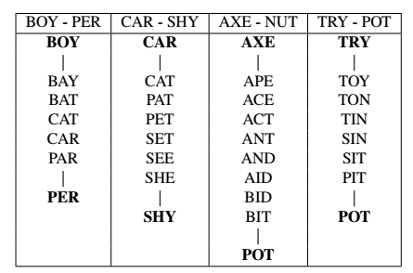
Fig.1. Word Morph Instances.
The rest of this paper is organized as follow. The next section reviews the literature related to finding graph structures for specific datasets. Section III details the serial ANG algorithm. Section IV is dedicated to describe all implementation of the parallel ANG. In the last two sections, the main results are presented followed by conclusions and future work.
2. Related Works
Most of the strategies used to generate graph structures for data sets employ statistical methods. A typical way of classifying them is taking into account the randomness adopted in the graph structure generation, that is, if it is random or non-random. Regarding the random methods, the results obtained by [6] in the study of the small-world phenomenon have been explored in the modeling of graph structures for a variety of real networks. This is the case of [7] who studied the search for data in large information networks and [8, 9] who analyzed the small-world problem as an intrinsic characteristic of any type of network. The concept of topology was also explored by [10] in the construction of random graphs for collections of textual documents.
The second category of strategies to generate graph structures, i. e., non-random methods, have been found to be more useful for both theoretical and practical purposes. An example is the recursive matrix model proposed by [11] that can generate realistic graphs efficiently. Other network topology models were explored by [12] who applied them to generate graph structures for backbone networks. The online probabilistic topological mapping proposed by [13] also represented a relevant advance in the problem of finding the graph structure of an environment from a sequence of measurements.
3. Serial ANG
The serial algorithm proposed by [4] is composed of three main steps:

- A relation is built between each pair of elements from a supplied dataset.
- A graph is built from the relations identified in the previous step.
- Topological neighborhoods are built based on an analysis conducted over the constructed graph.

Since the algorithm was fundamentally applied for solving word morph problems, the Levenshtein distance was employed to describe the relation pointed out in the first step. According to [14], the Levenshtein distance between two strings is the minimum number of character changes, insertions, and deletions required to transform one string into the other. Considering that the scope of the problems addressed by the ANG algorithm authors involves words with the same number of letters, the relation R between two elements (words) w₁ and w₂ was described as R(w₁, w₂): L(w₁, w₂) =
1, where L corresponds to the Levenshtein distance.
The second core concept explored by the algorithm is the graph whose structure is derived from the relation identified among the elements. Based on this premise, the following translation is carried out:

- Each word wi of the supplied dataset is treated as a vertice of the graph;
- There will exist an edge between two vertices w_{i} and w_{j} if, only if, the relation R(w_{i}, w_{j}) is verified.

The last step of the algorithm explores the concept of vertex neighborhood. For each vertex (word) v_{i} of the built graph G (dataset), its neighborhood N_{i} corresponds to all vertices v_{ij} directly connected to it. More formally

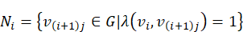 (1)

where j = {1, 2, ..., |N_{i}|} and λ is the Levenshtein distance.
By applying the ANG algorithm to the Word Morph problem, it actually constructs the shortest path from the initial word to the target word. To ensure that cycles are eliminated during the dataset traversal process, Serial ANG organizes the generated neighborhoods into levels. This topological structure has a direct impact on the selection of elements that will compose each neighborhood. In fact, considering the neighborhood N_{i} of a vertex v_{i}, the neighborhood N_{i+1} is defined as

(2)
4. Parallel ANG
Based on the same concepts as Serial ANG, its parallel version has been proposed. Parallel ANG preserves the original neighborhood definition as well as the way they are arranged in levels. By using structures that implement these concepts, the new algorithm also generates the shortest path between a pair of vertices and does not create cycles in the associated graph. The core strategy of the algorithm relies on the producer-consumer paradigm [15]. The paradigm proposes that a parent process called the producer works on the input information and generates outputs that will be submitted to the child process known as the consumer. The consumer, in turn, will work with the information received and then generate results that will be transferred to the next consumer in the producer-consumer chain. Following this strategy, the intermediary processes play both the roles of consumers and producers.
Based on Flynn’s Taxonomy, that paradigm was implemented in a Multiple Instruction Stream – Multiple Data Stream (MIMD) architecture [16]. More precisely, a shared-memory system with multi-core core processors was employed to model the parallelism of the ANG algorithm [17]. The main idea involves using threads for acting as consumers or producers at each level of the topological structure structure induced during the traversal of the graph. Figure 2 sketches how such a paradigm was tailored to the algorithm dynamics.

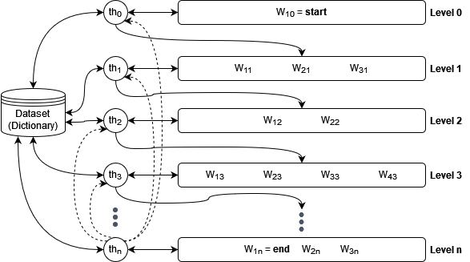
Fig.2. Parallel ANG Producer-consumer Schema.
The first thread (th₀) is assigned to the first level (level 0) which is responsible for starting the algorithm operation, that is, the producer-consumer chain. As this level holds only the start word of the problem instance, th₀ plays the producer role for the next level which is under the responsibility of another thread (th₁). Thread th₀ searches the dataset or dictionary for all words whose Levenshtein distance from the start words is equal to 1; the result of this searching corresponds to the production of th₀. Note that as soon as a word is returned by th₀ search, it is immediately pushed to the next level. On the other words, th₀ produces a stream of words that differ from the words belonging to its own level
(only one word - the start word - in the case of level 0) by just one letter.
A thread finishes processing the level under its responsibility when there are no more words in the dataset differing just one letter in comparison to any word in the level. In this case, the thread is allocated to the next available level. It is worth mentioning that a control has been implemented to ensure that each word in the dataset is used only once. Consequently, the algorithm also does not build cycles. When any thread (at any level) hits the end word, it notifies all other threads. This causes the producer-consumer chain to be interrupted. In Figure 2, this broadcasting (represented by the dashed arrows) is triggered by thread th_{n}.
On the other hand, if there is no a path between the start and end words, that is, there is no solution for the word ladder instance, thus the threads will process each level exhaustively. This scenario corresponds to one of the worst cases of the algorithm. The other one is when there is a path between the given words and each intermediate word of that path corresponds to the last word processed by the thread at its respective level. In Figure 2, this last scenario would be represented by the path {w₁₀, w₃₁, w₂₂, w₄₃, . . . , w_{3n} = end }, i. e., each last word of each level composing the path from start word to end word. Naturally, the best case happens when the first word of each level corresponds to a step of the path that connects the given words.
Figure 3 details an example of how the parallel ANG algorithm works. It builds a path between the amber and urges words. Three threads are responsible for processing the words at each level - subscript indices indicate the threads ID. The processing flow can be followed through the clock cycles represented by superscript indices. Hence, the arrow label represents a thread whose ID is n that is processing a word in the m clock cycle. For example, indicates that thread 2 is processing a word in clock cycle 4. The dashed arrows describe all unsuccessful attempts to find the target word. The path between the given words is indicated by the sequence of solid arrows.

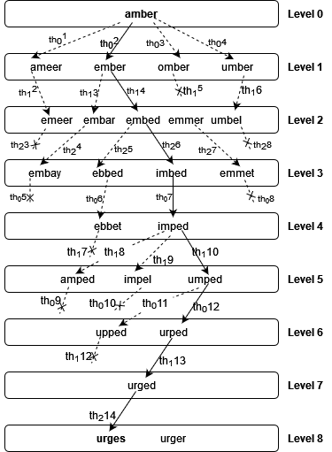
Fig.3. Example of Parallel ANG Working.
As shown by Figure 3, the word ladder instance was solved with an 8-step path - {amber, ember, embed, imbed, imped, umped, urped, urged, urges}. The solution was found after 14 clock cycles and was reached by thread 2. Note that, in this case, the broadcast triggered by this thread had no effect on the producer-consumer chain as there was no pending work in progress.
The proposed approach is detailed more precisely by algorithm 1 (Fig. 4.). It uses a set of additional structures (arrays) to control how threads process words per level (lines 2-6). The broadcasting mechanism is implemented by a shared variable (found) that is set when a thread hits the target word (lines 26-29). The threads’ work distribution in levels is managed by the array wlevel that holds the level each word belongs to. Basically, each thread goes through this array continuously looking for words whose associated level corresponds to the one it is responsible for. In addition to this condition, before processing a word, a thread also checks if that word has not been used by another one. Both conditions are verified in line 21.
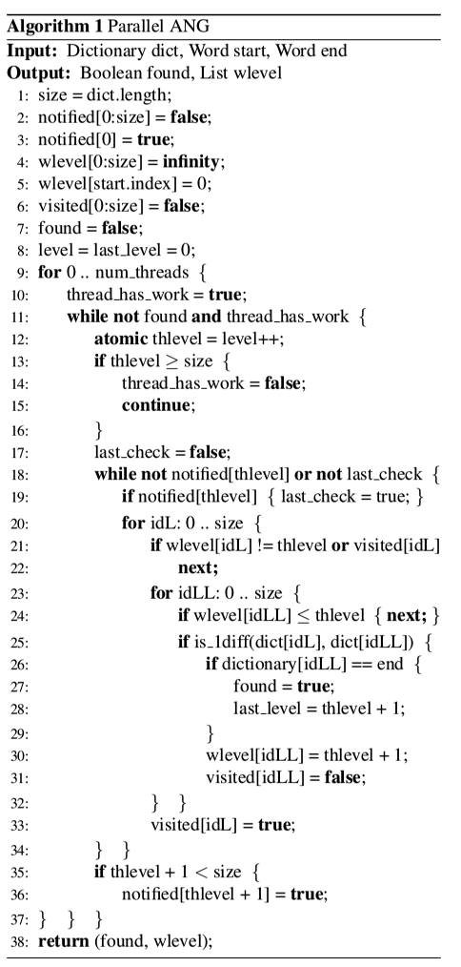
Fig.4. Parallel ANG Algorithm.
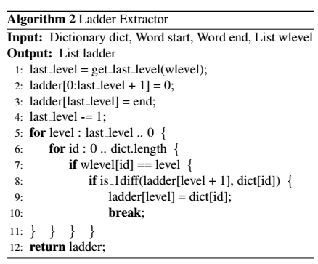
Fig.5. Ladder Extractor.
The algorithm generates a topological data structure that relies on another additional procedure (Algorithm 2 – Fig. 5.) to assemble the solution. This algorithm uses the same wlevel array to map the words at each level to another array (ladder) that corresponds to the path connecting start and end words. Naturally, this procedure is invoked only if a solution was found by the parallel ANG algorithm.
5. Results
Both the original ANG algorithm and the parallel algorithm proposed by this work were coded in the Rust programming language - version 1.48.0. The experiments were performed on a PC running Ubuntu Linux operating system, version 14.04.5 LTS, with Kernel version 3.19.0-31. It consists of one Intel i7-3610QM processor of 4 cores (two threads per core), operating at 2.3 GHz. Each core has a unified 256KB L2 cache and each processor has a shared 6MB L3 cache. The PC contains 8GB of main memory. The complete source code is available on GitHub repository [18]. The word ladder instances were adapted from an academic material produced for advanced programming assignments [19]. The dictionary consists of 183,719 words and each of the 23 test cases corresponds to word pairs ranging from 4 to 9 letters. Both the dictionary and test cases are also available on GitHub repository [18]. Thus, the accuracy and reliability of the results presented can be verified by cloning the repository and running the project.
As detailed in Table 1, the parallel ANG achieved outstanding results considering the CPU time. In fact, the proposed algorithm presented better performance for 21 test cases and the improvement rate was from 10.12% (instance 7) up to 99.85% (instance 21). In all cases, both algorithms found the shortest path between the given words. Such a significant decrease in the time required for solving the test instances was expected, since the generation of the underlying graph is interrupted as soon as the optimal solution is reached. Note that this strategy was found to be efficient even for very small instances. It turns out that the additional cost related to instantiating and managing multiple threads is cheaper than going through the full graph construction. Another natural consequence is the reduced use of main memory given that only a narrow part of the graph must be stored.
Table 1. Results Comparison. The Steps Column shows the Number of Intermediate Words that Make up the Path between Start and End words. The Reduction Column Indicates the rate of CPU time Reduction Achieved by the Fastest Algorithm Compared to the other.
Input |  |  | Steps (#) | CPU Time (sec.) |  | Reduction (%)
# | Start | End | Steps (#) | Serial | Parallel | Reduction (%)
01 | monk | perl | 5 | 0.340 | 0.394 | 13.71
02 | slow | fast | 5 | 0.366 | 0.248 | 21.31
03 | blue | pink | 5 | 0.316 | 0.417 | 24.22
04 | stone | money | 9 | 1.520 | 1.279 | 15.86
05 | money | smart | 9 | 1.546 | 1.270 | 17.85
06 | devil | angel | 8 | 1.483 | 1.076 | 27.44
07 | atlas | zebra | 11 | 1.552 | 1.395 | 10.12
08 | babes | child | 8 | 1.526 | 1.311 | 14.09
09 | mumbo | ghost | 9 | 1.516 | 1.335 | 11.94
10 | train | bikes | 9 | 1.513 | 1.080 | 28.62
11 | babies | sleepy | 13 | 4.809 | 2.209 | 50.47
12 | charge | comedo | 20 | 5.551 | 2.560 | 53.88
13 | boyich | painch | 31 | 6.916 | 2.501 | 63.84
14 | brewing | whiskey | 21 | 11.749 | 2.263 | 80.74
15 | chantry | swither | 7 | 11.563 | 0.389 | 96.63
16 | postman | bankers | 8 | 11.498 | 0.449 | 96.09
17 | careers | outline | 12 | 11.603 | 1.918 | 83.47
18 | dancers | leading | 14 | 11.557 | 2.038 | 82.37
19 | atlases | cabaret | 41 | 11.683 | 3.320 | 71.58
20 | quirking | wrathing | 20 | 126.339 | 0.584 | 99.54
21 | gestates | ravelled | 7 | 56.410 | 0.087 | 99.85
22 | creative | whacking | 7 | 195.665 | 0.335 | 99.83
23 | decanting | derailing | 16 | 16.141 | 0.077 | 99.52

A significant speedup of the algorithm was also observed with the longest word pair, i. e., the 9-letter words (decanting, derailing). When running the algorithm with 4 threads, the best performance improvement (2.01X) was obtained in that instance. On the other hand, the use of a larger number of threads caused a degradation of the algorithm speedup. Such a result was expected since the tests were performed on a 4-core processor. All this behavior is graphically described in Figure 6.
Although speedup was constrained by computational resources - basically the number of processor cores – within the range of available cores this metric did not scale as one might suppose. In fact, from 2 to 4 threads the speedup rate was lower than the first interval. This might suggest some bottleneck in the algorithm that is constraining its scalability. Another aspect to note is that the algorithm did not take advantage of the hyper-threading feature available on the CPU. When using this feature, its performance was expected to speed up to 8 threads, which was not observed as mentioned earlier.

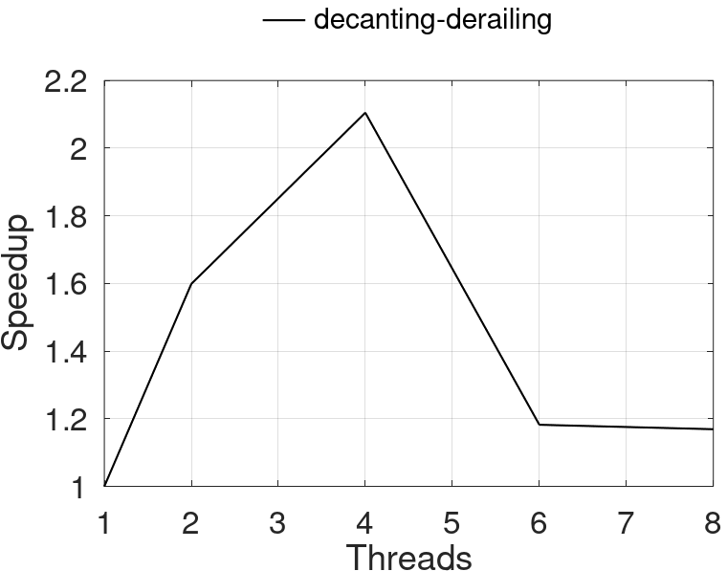
Fig.6. Speedup of Parallel ANG.
6. Conclusion
This work presented a fast parallel algorithm based on the serial ANG algorithm designed to build graph structures from large data sets. The proposed strategy was demonstrated by applying it to the word ladder game. Addressing the intrinsic characteristic of the serial algorithm related to the construction of the complete structure of the graph, the new algorithm offers an efficient alternative when generating the graph on demand. More precisely, the parallel algorithm gradually builds the graph and stores it in main memory until the word ladder solution is found. In this way, this new strategy constitutes a more efficient approach regarding the use of computational resources. The achieved results also endorse the improvements related to CPU time. For the set of tested instances, the attained time reduction varies between 10.12% and 99.85%. Other significant results show the parallel ANG algorithm achieving speedups up to 2.01X with 4 threads. Considering the quality of the solutions, that is, the sequence of intermediate words separating two input words, the shortest path was also obtained by the parallel version of the algorithm. This means that the accuracy provided by the original algorithm was maintained.
As the topological approach presented by the serial ANG algorithm was also preserved, this new parallel version may be straightforwardly adapted to traverse large datasets. In fact, a significant next algorithm evaluation should involve a test of its performance to sort log files as proposed by the work [4]. Regarding the algorithm performance, it showed speedup improvements only up to 4 threads. Thus, another very important analysis to be performed is to submit it to a stricter profiling procedure. This approach can detect any bottlenecks that are limiting the scalability of its performance.
References
- H. Xingwei, “Sorting big data by revealed preference with application to college ranking,” Journal of Big Data, vol. 7, no. 30, pp. 1–26, 2020.
- Y. Chi, X. Cheng, C. Song, R. Xia, L. Xu, and Z. Li, “Sorting and utilizing of telecom operators’ data assets based on big data,” in 2019 IEEE International Conferences on Ubiquitous Computing Communications (IUCC) and Data Science and Computational Intelligence (DSCI) and Smart Computing, Networking and Services (SmartCNS), pp. 621–625, 2019.
- Y. Zhan and K. H. Tan, “An analytic infrastructure for harvesting big data to enhance supply chain performance,” European Journal of Operational Research, vol. 281, no. 3, pp. 559–574, 2020.
- J. Klüver, J. Schmidt, and C. Klüver, “Word morph and topological structures: A graph generating algorithm,” Complexity, vol. 21, pp. 426–436, sep/oct 2016.
- S. Iyengar, N. Zweig, A. Natarajan, and V. Madhavan, “A network analysis approach to understand humanwayfinding problem,” in Proceedings of the Annual Meeting of the Cognitive Science Society, vol. 33, pp. 2836–2841, 2011.
- S. Milgram, “The Small-World Problem,” Psychology Today, vol. 1, no. 1, pp. 61–67, 1967.
- J. M. Kleinberg, “Small-world phenomena and the dynamics of information,” in Advances in Neural Information Processing Systems 14 [Neural Information Processing Systems: Natural and Synthetic, NIPS 2001, December 3-8, 2001, Vancouver, British Columbia, Canada], pp. 431–438, MIT Press, 2001.
- D. Watts, Small Worlds: the dynamics of networks between order and randomness. Princeton Univ Pr, 1999.
- D. J. Watts and S. H. Strogatz, “Collective dynamics of ‘small-world’ networks,” Nature, vol. 393, no. 6684, pp. 440–442,
1998.
- J. Leskovec and J. Shawe-Taylor, “Semantic text features from small world graphs,” in Subspace, Latent Structure and Feature Selection techniques: Statistical and Optimization perspectives Workshop, Slovenia, 2005.
- D. Chakrabarti, Y. Zhan, and C. Faloutsos, “R-mat: A recursive model for graph mining,” in SIAM International Conference on Data Mining, 2004.
- A. Mahmood, A. Jabbar, E. K. Cetinkaya, and J. P. G. Sterbenz, “Deriving network topologies from real world constraints,” 2010 IEEE Globecom Workshops, pp. 400–404, 2010.
- A. Ranganathan and F. Dellaert, “Online probabilistic topological mapping,” The International Journal of Robotics Research, vol. 30, no. 6, pp. 755–771, 2011.
- J. Leeuwen and J. v. Leeuwen, Algorithms and Complexity. Elsevier Science, 1990.
- A. Prat-Perez, D. Dominguez-Sal, J.-L. Larriba-Pey, and P. Trancoso, “Producer-consumer: The programming model for future many-core processors,” in Architecture of Computing Systems – ARCS 2013 (H. Kubátová, C. Hochberger, M. Danek, and B. Sick, eds.), (Berlin, Heidelberg), pp. 110–121, Springer Berlin Heidelberg, 2013.
- M. J. Flynn, “Very high-speed computing systems,” Proceedings of the IEEE, vol. 54, pp. 1901 – 1909, December 1966.
- P. Pacheco, An Introduction to Parallel Programming. San Francisco, CA, USA: Morgan Kaufmann Publishers Inc., 1st ed., 2011.
- T. N. Rodrigues, “Parallel ANG Algorithm for the Word Ladder Game.” https://github.com/tnas/word-ladder, 2021.
- V. S. Adamchik, “S&Q: Word Ladder.” https://viterbiweb.usc.edu/ adamchik/15-121/labs.html, 2009.

Authors’ Profiles


Thiago Nascimento Rodrigues holds a bachelor’s degree in Computational Mathematics from the Federal University of Minas Gerais (UFMG), Brazil. Before his master’s degree, he specialized in computer network infrastructure for IT business environments at Faculdades Integradas Espírito-Santenses (FAESA), Brazil. His master’s degree in Informatics was obtained at the Federal University of Espírito Santo (UFES), Brazil, and was focused on the parallelization of irregular algorithms for reordering sparse matrices. For the last decade, he has been a software engineer on large enterprise systems projects for the Brazilian government.

How to cite this paper: Thiago Nascimento Rodrigues, "A Fast Topological Parallel Algorithm for Traversing Large Datasets", International Journal of Information Technology and Computer Science(IJITCS), Vol.15, No.1, pp.1-8, 2023. DOI:10.5815/ijitcs.2023.01.01

