Analysis and Numerical Simulation of Deterministic Mathematical Model of Pediculosis Capitis

**Emeka Emmanuel Otti**\*

Department of Mathematics and Statistics, Federal University Wukari, 67010, Nigeria

E-mail:[emeka.otti@fuwukari.edu.ng](mailto:emeka.otti@fuwukari.edu.ng)

ORCID iD: https://orcid.org/0000-0002-9399-5048

*Correponding Author

**Ebelechukwu C. Okorie**

Department of Mathematics and Statistics, Federal University Wukari, 67010, Nigeria

E-mail:[okoriec636@gmail.com](mailto:okoriec636@gmail.com),

ORCID iD: https://orcid.org/0000-0001-5006-1870

**Sunday M. Bulus**

Department of Mathematics and Statistics, Federal University Wukari, 67010, Nigeria

E-mail: [sunday.bulus@fuwukari.edu.ng](mailto:sunday.bulus@fuwukari.edu.ng)

ORCID iD: https://orcid.org/0000-0001-7476-7659

Received: 11 October, 2022; Revised: 24 November, 2022; Accepted: 24 December, 2022; Published: 08 February, 2023

**Abstract:** In this work, we formulated a deterministic mathematical continuous time model for the detection and elimination of a non-life threatening disease (head lice) by considering a fixed (constant) population size during the epidemic period. The formulated mathematical model was normalized for easy analysis, the model’s properties were obtained, as well as the disease free equilibrium point, the local stability and the basic reproduction number. We adopted MATLAB programing language to carry out the numerical simulation of the nonlinear ordinary differential equation, as well as simulation of different model state variables and effects of different model parameters on the state variables over time. Our result shows that early detection and treatment will lead to termination of the disease.

**Index Terms:** Pediculosis Capitis, Disease Free Equilibrium, Local Stability, Basic Reproduction Number and Equilibrium Analysis.

1. **Introduction**

Pediculosis capitis is the state of having an infestation of head lice. Lice are external parasitic insects that are commonly found on the eyelashes, head and eyebrows of human as its host. Pediculosis humanus capitis, commonly known as head lice resides close to the scalp of the head to maintain its body temperature and feeds extremely on human blood to survive. There are thousands of external parasite that feeds on human blood known as lice, but only few of them namely: Pediculus humanus capitis (head lice), Pediculus humanus corpon’s (body or clothing lice) and Phthirus pubis (pubic or crab lice) that infest human population [1]. Out of the three aforementioned ectoparasites that infest human populations, Pediculus humanus capitis (Head lice) are the most common species and are of public concern in most developing countries lacking the juicy world health organization (WHO) primary health care program [2]. This ectoparasite (head louse) neither moves by crawling nor flies or hop and as such it’s mainly transmitted or contacted via head-to-head contact with an infested person [3]. Head lice infestation (epidemics) often occur in kindergartens and schools during classroom activities where head-to-head contact is possible, during riding the school bus and during play [4], thus infesting other members of their families at home.

Pediculus humanus capitis (head lice) go through three stages in their life cycle namely egg, nymph and adult louse. The adult female louse lays egg usually called nits. The nits are hard to see and most a times are mistaken for hair spray droplets or dandruff, located at the base of the hair shaft and usually takes (8-9) days to hatch [5]. After exiting the first stage, the nymph an immature louse moults three (3) times before becoming adult in about (7-12) days sequel to hatching. It appears like an adult head louse however it is about the size of a pinhead [5], and feeds on human blood to survive. The last stage, is the adult stage, the adult is tan to grayish white in color and is about the size of a sesame seed with 6 legs. The life span of adult lice on human head is 30 days, and feeds extremely on human blood between 3 and 10 times daily as its meal. Once it is shaken off human head, it only last few hours [6] without a blood meal.

Pediculus humanus capitis (head lice) infestation affect majorly children within age bracket of 3 and 11 years old, independent of their socio-economic status, religion, tribe, country of origin, color of skin, gender and ethnic group [7]. Its symptoms such as scratching, a tickling feeling of moving object in the hair and itching usually occurs as soon as the human host develops an allergic reaction to the saliva of the head lice, often normally (4-6)weeks including the first day of infestation. Early detection of the head lice infestation on the host scalp and hair will help the host to respond to treatment such as wet combing, oral treatment and topical application of Pediculosis [7] positively. Though pediculus humanus capitis (head louse) is not known to cause life threatening disease, for some decades now, it has remain a constant source of disturbance both to public health officials and parents of the infested children. Globally, head lice prevalence takes the range 0-59% in different regions and a prevalence of more than 5% is considered to be epidemic [8]. Over a decade, several studies carried out in some cities in Nigeria such as Ilorin in 1988, Ibadan in 2006 (amongst primary school children), Ile-Ife in 1985 and Ibadan in 1984 (among rural and urban areas) reveals prevalence rate of 0.1-3.1%, 16.7%, 12.7%, respectively [9-12]. Thus our motivation to narrow our research work to primary schools in Northern Nigeria due to high prevalence rate recorded in schools

Whereas mathematical model of some ectoparasites such as sea lice [13], ticks [14] and fleas [15] and are well established, to the best our knowledge only few mathematical stochastic model have been proposed to study the dynamics of pediculosis (head lice) infestation with non in deterministic model. [16] Introduced an epidemic model based on stochastic susceptible – infectious – susceptible (SIS). The model take into consideration a fixed population size of N, divided into two compartments namely, susceptible compartment S(t) and infectious compartment I(t) at time (t) where  and  Also, [17] proposed a model for endemic infectious based on a stochastic SIS (Susceptible-Infectious-Susceptible) epidemic model taking into consideration addition of external source of infection. They used “the stationary distribution of the number of infected individuals, in conjunction with data from a recent study carried out in Welsh schools on the prevalence of head lice infections, and employed maximum likelihood methods to obtain estimates of the model parameters.”

To study the infestation of pediculosis (Head lice), we adopt and modify the deterministic (continuous time) model proposed by [18], where the authors considered permanent immunity after recovery. In their work, total population  was considered constant and individuals in the population were subdivided into three (3) classes, namely, Susceptible Class, Infected Class and Recovered Class. Their model was uniquely developed to consider infectious diseases such as typhoid fever, small pox and mumps where permanent immunity is acquired upon recovery. Consequently, we have formulated a continuous time deterministic mathematical model to study the dynamics of pediculosis infestation by considering a fixed or constant population and to achieve this we assume  In our model, we assume that recovered individuals immediately returns to the susceptible class for possible re-infestation, since there is no any form of immunity either temporary or permanent for pediculosis (head lice) infestation.

We organize the remaining section of this research work as follows: In section two (2), we described the basic model and its properties; in section three (3), we present the model analysis and in section four (4), we discussed the numerical simulation and results of the proposed mathematical model.

1. **Mathematical Model Formulation**

*2.1 Compartmental Model Description*

First and foremost, we divide total fixed or constant population size (at time t, where )denoted by  into three (3) classes: Susceptible Class,  [Individuals who maybe infested], Infested Class,  [Individuals who are infested and can transfer to others] and Recovered Class,  [Individuals who have recovered and have no any form of immunity]. This model assumes that the population  is consistently mixing. It is assumed that the rate of recruitment (immigrant)  into the susceptible class  is constant, upon contact with infested individuals, susceptible individuals get the infection and move into the infected or infested class at a rate where the rate of infective contact is. In addition, it is assumed that infested individuals recover and move into the Recovered Class at a rate  and also at the rate  for early detection and treatment. Since, our model assumes that there is no any

form of immunity, the recovered individuals immediately return to the Susceptible Class at a rate . Lastly, all classes ( experience natural death or death due to other ill health at a rate .

*2.2 Variable and Parameter Definition*

The table below (Table 1 and Table 2) describe clearly the model variables and parameters used:

Table 1. Model Variable Used

|  |  |
| --- | --- |
| Variable | Definition |
| S $⇒$ Susceptible  I $⇒$ Infested  R $⇒$ Recovered  N $⇒$ Population | The class of individuals susceptible at time t.  The class of individual infested at time t.  The class of individuals who recovered at time t.  The total population at time t. |

Table 2. Model Parameter Used

|  |  |
| --- | --- |
| Parameter | Definition |
|  | Natural death rate  Recruitment rate (immigration).  Pediculosis transmission rate  Rate at which infested individuals recover after awareness and treatment (control rate).  Recovery rate  Rate at which recovered individual return to the susceptible class. |

*2.3 Compartmental Flow Diagram*

S

I

R

$$ϑN$$

$$\frac{βSI}{N}$$

$$δI$$

$$μS$$

$$μI$$

$$μR$$

$$φR$$

Fig. 1. Schematic Compartmental Flow Diagram of Pediculosis Capitis

*2.4 Mathematical Model Equation*

Taking to heart or reminiscing our model assumption in subsection $(2.1)$ and the compartmental flow diagram in subsection $(2.3)$ above, a deterministic (continuous time) model is formulated as follows:

 (1)

 (2)

 (3)

Let be any solution with positive initial conditions, that is 

Then we have that



Consequently, the time derivative of the total population $N\left(t\right),$ that is summation of equation (1-3) is given

() + ()+

() - (S + I + R)

N’(t) =  (4)

*2.5 Dimensionless Transformation*

In order to simplify the model analysis, we carry out dimensionless transformation by adopting the approach used by [19, 20] of scaling the population of each class by the total population.

Thus,



Using the state variables $s, i and r,$ the normalized model system becomes:

 (5)

 (6)

 (7)

Adding equation (5-6) yields

 (8)

where



*2.6 Positivity Solution*

In this subsection, we show that all state variables in the SIR model are non-negative, since they represent human population.

**Lemma 1.** Let  be a set of non-negative region in , then the solution set  is positive 

**Proof** Considering the systems of equation in equations (5-7),

For equation (5),





 (9)

Solving equation (9) yields





For equation (6),





 (10)

Solving equation (10) yields





Lastly, for equation (7),





 (11)

Solving equation (11) yields



Thus, the proof that all state variables are positive $∀ t ≥0$.

*2.7 Feasible Region*

Since the population in consideration is human population, all state variables in the SIR model remains positive all the time. Thus, the model system equations (5-7) in the region $Ω$ is restricted to a non-negative condition.



where 

Our model equation (5-7) is biologically meaningful where the feasible region is positively invariant otherwise it is not.

1. **Model Analysis**

*3.1 Equilibrium Analysis*

Here we carried out stability analysis to determine the disease free equilibrium point (DFE) of the model. To determine the disease free equilibrium point (DFE), we equate each equation in equation (5-7) to zero, that is thus yielding

 (12)

 (13)

 (14)

From equation (12 - 14) above, we can obtain the equilibrium points 

*3.2 Disease Free Equilibrium (DFE)*

The model’s disease free equilibrium is obtained by equating  that is a condition where there is no spread of pediculosis.

From equation (14) above,



From equation (12) above,



Therefore, the disease free equilibrium points for pediculosis are:



*3.3 Local Stability*

The local stability of the disease free equilibrium is computed using Jacobian matrix of equation (5-7) at the disease free equilibrium point

.

We obtain the Jacobian matrix of equation (5-7) as follows

 (15)

then

 (16)

At the disease free equation



 (17)

Now, we compute the eigenvalues of equation (17). Outcome of the eigenvalues will determine whether the disease free equation ($D^{0}$) is locally asymptotic stable or not.

Let



be a characteristics equation.

Then,

 (18)

 (19)

Evaluating equation (19) abrove yields







Since all the eigenvalues of $J\left(D^{0}\right) <1$ that is < $1$, therefore the disease free equilibrium is locally asymptotically stable (LAS).

*3.4 Basic Reproduction Number ($R_{0}$)*

In this subsection, we obtain or compute the basic reproduction number ($R_{0}$) which is defined as the number of secondary infection produced by a single infective individual when introduced into a completely susceptible population. In order to obtain the basic reproduction number ($R_{0}$), we adopt the same approach used in [20] where the authors used two matrices $F and V$, with $F$ representing the new infection terms and $V$ representing the remaining terms of transfer.

Our model has only three (3) compartments with only one (1) infective compartment.

From equation (6),



We have that



and



We obtain the matrices $F and V$ by taking the Jacobian of $F and V$ respectively at the disease free equilibrium, $D^{0}.$





At disease free equilibrium, the matrix $F$ becomes



Also,



At disease free equilibrium, the matrix $V$ becomes



The inverse of matrix $V$ becomes



Let



Then



 (20)

Using the characteristics equation  we compute the eigenvalues of equation (20) as follows



Where $I$ is an identity matrix (in this case, it is 1).



Therefore, the basic reproduction number ${ (R}_{0}$) is given as



1. **Simulation and Discussion of Result**

*4.1 Simulation*

To simulate the formulated mathematical model in equation (5-9), we adopted MATLAB programming language using parameter values presented in Table C below. Due to unavailability of some of these parameter values, we obtain them from different sources, estimated some and assumed some of the parameter values.

Table 3. Model Parameter Values Used and Their Sources

|  |  |  |
| --- | --- | --- |
| Model Parameter | Model Parameter Value | Sources of Model Parameter Value |
|  | 0.0500  0.0500  0.0100  [0.0000,0.2000,0.4000,0.6000,0.8000]  0.2000  0.2000 | Assumed  Assumed  [14]  Assumed  Estimated  Estimated |

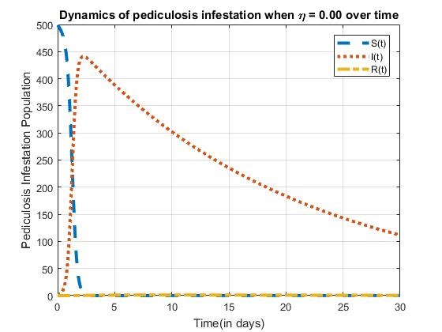

Fig. 2. Dynamics of pediculosis infestation when $η=0.00.$

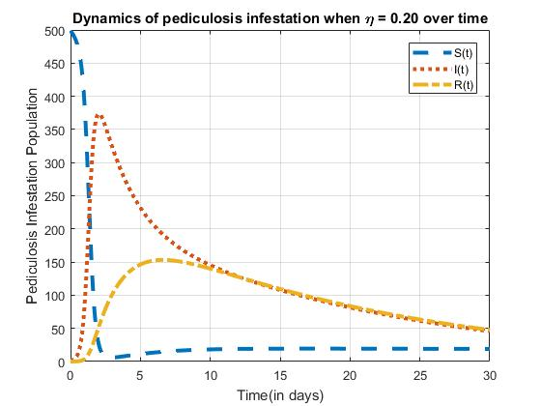

Fig. 3. Dynamics of pediculosis infestation when $η=0.20$

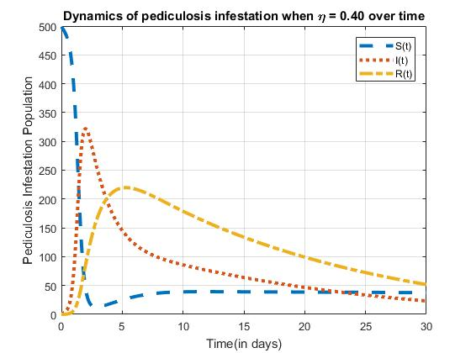

Fig. 4. Dynamics of pediculosis infestation when $η=0.40$

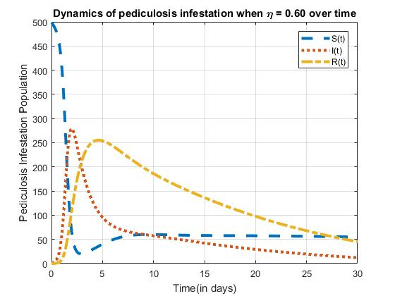

Fig. 5. Dynamics of pediculosis infestation when $η=0.60$.

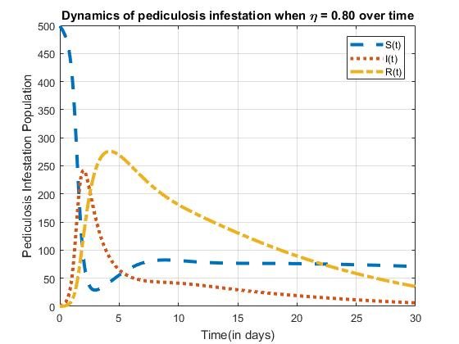

Fig. 6. Dynamics of pediculosis infestation when $η=0.80.$

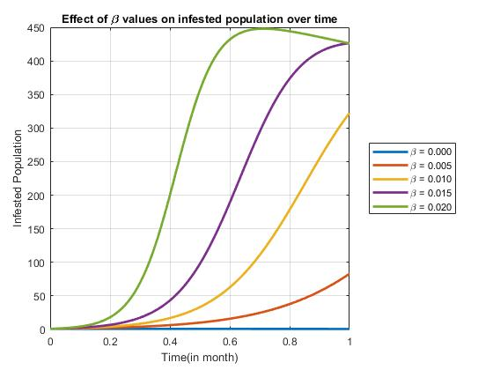

Fig. 7. Effect of different $β$ values on infested population over time

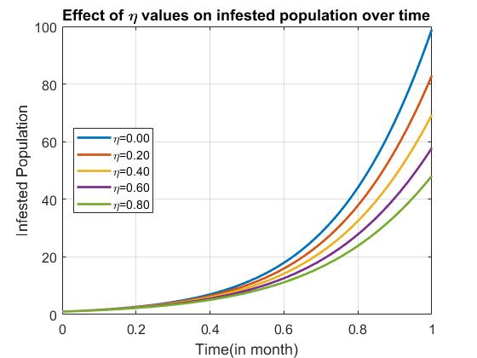

Fig. 8. Effect of different $η$ values on infested population over time

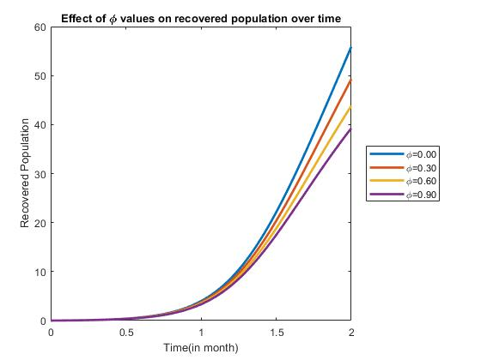

Fig. 9. Effect of different $ϕ$ values on recovered population over time.

*4.2 Discussion of Results*

In order to have clear insight of the dynamics of pediculosis capitis, we displayed nine (9) figures for parameter analysis.

Figure (2-6) above shows the dynamics of pediculosis infestation for different values of $η$. We observed that as the value of $η$ increases, the population of the infested individuals reduces thus leading to the increase in the population of the recovered individual over time. We also observed that as the $η$ values increase, it takes shorter time for the infested population to reduce. Biologically, it implies that pediculosis capitis is curable over time within the population provided there is public enlightenment and treatment. The more the public are sensitized and treated, the more diminishing the disease becomes in the population.

Also, in figure 7, a simulation to visualize the effect of $β$ on infested population was carried out by varying the values of $β$. We held other parameter values constant as in Table 3 above and use different values of $β$ that is $β=\left[0.000, 0.005, 0.010, 0.015, 0.020\right].$ We observed that increase in $β$ values leads to increase in the infested population which totally agrees with our proposed model and gives us a linear relationship between $β$ and the infested population.

Furthermore, in figure 8 and 9, the outcome of the simulation for different values of $η$ that is $η=[0.00, 0.20, 0.40, 0.60, 0.80]$, holding other parameter values constant as in Table 3, shows that $η$ has an important effects on both the infested population and the recovered population over time. We observed from Figure 8 that increase in $η$ value leads to decrease in the infested population thereby giving us an inverse relationship between $η$ and infested population. Also, on the contrary, we observed from Figure 9 that increase in $η$ values leads to increase in the recovered population thus giving us a linear relationship between $η$ and the recovered population. From these relationships, we deduce that $η$ play a significant role in controlling the dynamics of pediculosis.

Lastly, in figure 10, we observed that increase in $ϕ$ values that is $ϕ=[0.00, 0.30, 0.60, 0.90]$ leads to decrease in recovered population, thus giving us an inverse relationship between $ϕ$ and the recovered population. This is in agreement with our model as the recovered individual’s returns to the susceptible class for possible infestation due to absence of any form of immunity either temporary or permanent.

1. **Conclusion**

A Mathematical model for transmission dynamics of pediculosis infestation is formulated and analyzed. The model has only one equilibrium namely disease free equilibrium point (DFE). Since the model’s basic reproduction number ($R_{0}$) is less than one (1), that is $R_{0}<1$, the disease free equilibrium point (DEF) is locally asymptotically stable (LAS). Also, numerical simulation is carried out and it was observed that the parameter $η$ plays a significant role in controlling the dynamics of pediculosis infestation. This work, however did not address the asymptomatic population. This work can be extended to incorporate the asymptomatic compartment to further investigate the dynamics of pediculosis capitis in a population.

**Acknowledgment**

The authors deeply appreciate the management of Federal University Wukari, Nigeria for providing enabling environment to carry out this research.

**References**

1. Gary LD, Robert S. Arthropod bites and infestations. In: Behrman RE, Kliegman RM, Jenson HB, (editors). Nelson Textbook of Pediatrics. 17th ed. Pennsylvania: Saunders; 2004; 2238-42.
2. Hadeel T. Al-Barrak. (2021) Prevalence of Head Lice *(Pediculus humanus capitis)* among Primary School Children in Baghdad Suburbs. Journal of, 21(1); 280-284.
3. Meister, L., Ochsendorf, F., 2016. Head lice: Epidemiology, biology, diagnosis, and treatment. Dtsch Arztebl Int 113, 763.
4. B.A.N Okoh and E.A.D Alikor. (2013) Pervalence of Head Lice Infestation in Primary School Children in Port Harcourt. *East African Medical Journal,* 90(8); 269 – 274.
5. American Academy of Pediatrics. Pediculosis Capitis (Head Lice). In: Pickering LK, Baker CJ, Kimberlin DW, Long SS, eds. *Red Book: 2012 Report of the Committee on Infectious Diseases*. Elk Grove Village, IL: American Academy of Pediatrics; 2012: 543-546.
6. Stephen, E. and N. Nyerere. (2015). A Mathematical Model for the Dynamics of Cholera with Control Measures. *Applied and Computational Mathematics.* Vol.4, No.2, pp.53-63. doi:10.11648/j.acm.20150402.14.
7. Feldmeier, H., 2012. Pediculosis capitis: new insights into epidemiology, diagnosis and treatment. Eur. J. Clin. Microbiol. Infect. Dis. 31, 2105–2110.
8. Speare R, Buettner PG. Head lice in pupils of a primary school in Australia and implications for control. *Int J Dermatol* 1999; 38: 285-90.
9. Ebomoyi E. Pediculosis capitis among primary school children in urban and rural areas of Kwara State, Nigeria. *J Sch Health* 1988; 58:101-3.
10. Olaitan OL. Head lice infestation among primary school children in Ibadan, Oyo State, Nigeria. *AJES* 2006; 4:134–40.
11. Jinadu MK. Pediculosis humanus capitis among primary school children in lie-ife, Nigeria. *J R Soc Promot Health* 1985; 105: 25-7
12. Ogunrinade AF, Oyejide CO. Pediculosis capitis among rural and urban school children in Nigeria. *Trans R Soc Trop Med Hyg* 1984; 78:590-2.
13. Revie CW, Robbins C, Gettinby G, Kelly L, Treasurer JW (2005). A mathematical model of the growth of sea lice, lepeophtheirus salmonis, populations on farmed atlantic salmon, salmo salar l., in scotland and its use in the assessment of treatment strategies. Journal of Fish Diseases 28: 603–613.
14. Beugnet F, Chalvet-Monfray K, Sabatier P (1998) Using of a mathematical model to study the control measures of the cattle tick boophilus micropilus populations in new caledonia. Veterinary parasitology 77: 277–288.
15. Beugnet F, Porphyre T, Sabatier P, Chalvet-Monfray K (2004) Use of a mathematical model to study the dynamics of ctenocephalide felis populations in the home environment and the impact of various control measures. Parasite 11:387–399.
16. Takano-Lee M, Yoon KS, Edman JD, Mullens B, Clark JM (2003) In vivo and in vitro rearing of pediculus humanus capitis (anoplura: Pediculidae). Journal of Medical Entomology 40: 628–635.
17. Patricia Stone; HildeWilkinson-Herbots and Valerie Isham (2008). A stochastic model for head lice infections. J. Math. Biol. 56:743–763
18. Kermack, W.O and McKendrick, A.G. (1927). A contribution to the mathematical theory of epidemics. *Proceedings of the Royal Society of London.* Series A, 115(772), 700-721.
19. Weiss, G., Dishon, M.: On the asymptotic behaviour of the stochastic and deterministic models of an epidemic. Math. Biosci. 11, 261–265 (1971).
20. Korobeinikov A, Wake GC (2002). Lyapunov function and global stability for SIR, SIRS and SIS epidemiological models, Appl. Math. Lett. 15:955-960.

**Authors’ Profiles**

**Emeka Emmanuel Otti** received the B.Sc. degree from Federal University Wukari (FUW), Nigeria in 2016, and the M.Sc. from African Institute for Mathematical Sciences (AIMS), Senegal in 2020, all in pure and applied Mathematics. He is currently a Lecturer in Mathematics and Statistics Department, Federal University Wukari, Nigeria where he currently lecture and conduct academic research. He has keen research interest in Mathematical Modeling, Biomathematics and Computational Fluid Dynamics. [emeka.otti@fuwukari.edu.ng](mailto:emeka.otti@fuwukari.edu.ng)

**Mrs. Ebelechukwu Charity Okorie** is currently employed as a Lecturer in the Department of Mathematics and Statistics, Faculty of Pure and Applied Science, Federal University Wukari, Nigeria. She obtained her B.Sc. from Nnamdi Azikiwe University Awka, Nigeria in 1998 and M.Sc. from Federal University of Technology Minna, Nigeria in 2012, both in Applied Mathematics. Her main research areas are Mathematical Modelling and Biomathematics. [okoriec636@gmail.com](mailto:okoriec636@gmail.com)

**Sunday Michael Bulus** graduated with with Summa cum laude in BSc Mathematics, from Federal University Wukari, Nigeria and holds a MSc from the University of Ibadan. He is a Lecturer and researcher at the department of Mathematics and Statistics, Federal University Wukari. His research interest centres around Mathematical Finance, modelling, Stochastic analysis and Probability. [sunday.bulus@fuwukari.edu.ng](mailto:sunday.bulus@fuwukari.edu.ng)

**How to cite this paper:** Emeka Emmanuel Otti, Ebelechukwu C. Okorie, Sunday M. Bulus, "Analysis and Numerical Simulation of Deterministic Mathematical Model of Pediculosis Capitis", International Journal of Engineering and Manufacturing (IJEM), Vol.13, No.1, pp. 1-13, 2023. DOI:10.5815/ijem.2023.01.01